**#4WEEK 4APP CHALLENGE**

**App-4**

**News App**

Description:

Welcome to our news app – your go-to source for staying informed and connected in real-time. Experience the latest news tailored to your preferences, explore diverse genres, and engage with dynamic features that empower you to become a part of the news-sharing community.

Key Features:

1. Latest News Feed: Stay updated with the most recent and relevant news from around the world. Our app ensures you are always in the know.

2. Customized News Feed: Tailor your news experience by selecting your desired genres. With a simple click on the "+" icon, users can add new genres and personalize their news feed.

3. Video Integration: Immerse yourself in the news through our video feature. Now, in addition to articles, stay informed with video content that brings stories to life.

4. Save News for Later: Never miss a story! Save articles of interest to read later. Your personalized reading list is just a tap away.

5. User-Generated Content: Take your engagement to the next level. Users can contribute to the news community by posting news stories, creating their own channels, and sharing valuable insights.

6. Follow and Be Followed: Foster connections within the news-sharing community. Follow your favorite contributors, channels, or fellow users. Additionally, users can build their audience by being followed.

Our news app is not just a platform for consuming news but a dynamic space where you actively participate in the creation, sharing, and consumption of information. Join us in redefining the news experience!

Android view

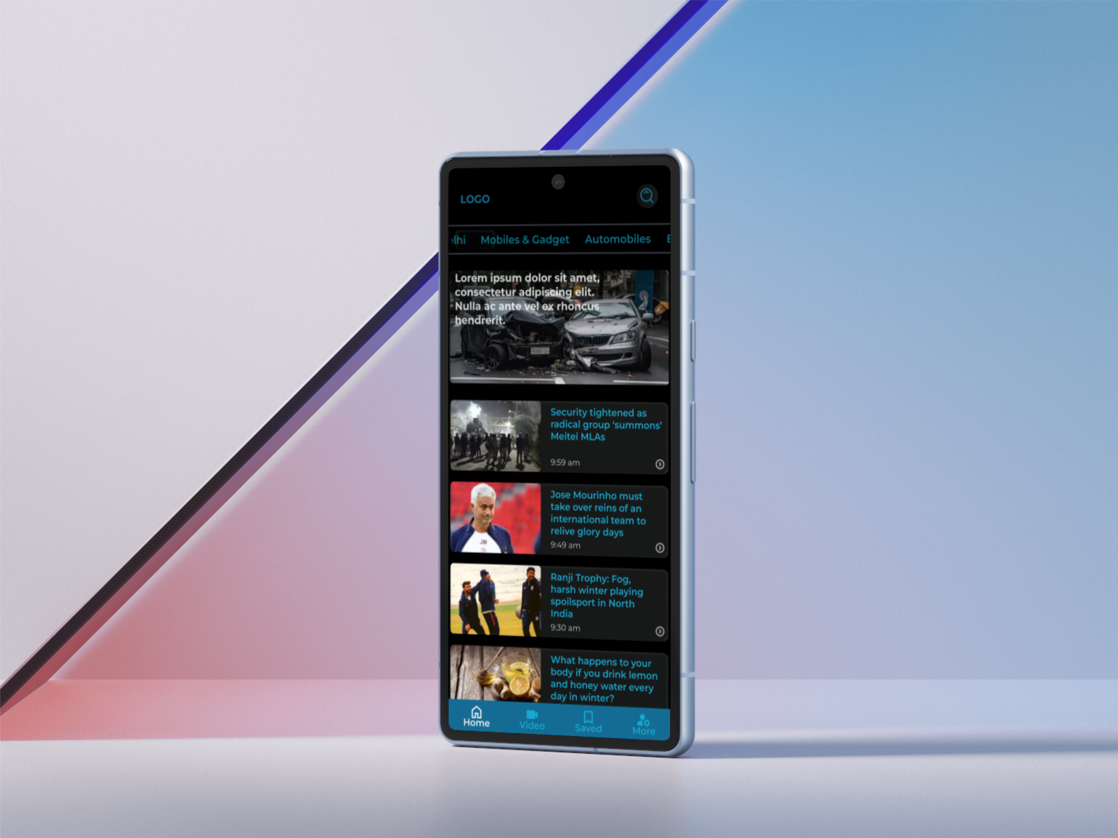

Link:-

<https://www.figma.com/proto/hYGSMXi1El2jceoXIl7yIU/app-practice-2?page-id=532%3A2&type=design&node-id=532-3&viewport=55%2C144%2C0.14&t=UwazLphaVSqYWO5v-1&scaling=scale-down&mode=design>